 

**Assessment Portfolio**

**Diana Savchuk**

**SQL: Introduction — DH3J 34 SCQF level 7**

Part 3

**Assessment Part 2**

**Assessment tasks**

# The following SQL Statements should be completed in APEX.

A screenshot should be taken of each completed statement and the Result. All the screenshots should be put into a Word document with an appropriate title (Task 1 Answer, Task 2 Answer etc….) and submitted to the Assessment Dropbox.

# Please note that all the tasks should be completed before submitting the Word document. There is a checklist at the bottom of this document to track your progress.

## Scenario

The Healthy Pets Veterinary Surgery is currently spread over two practices. The head office at 27, The Hill, Glasgow and a smaller, temporary practice at Unit 1, Houston Estate, Glasgow.

Currently there are four vets, two at each site. However, the plan for the future is to significantly expand the head office and close the temporary practice. All four vets will then work from the head office. Also, two new members of staff will be recruited.

A data model representing the current situation is shown below.

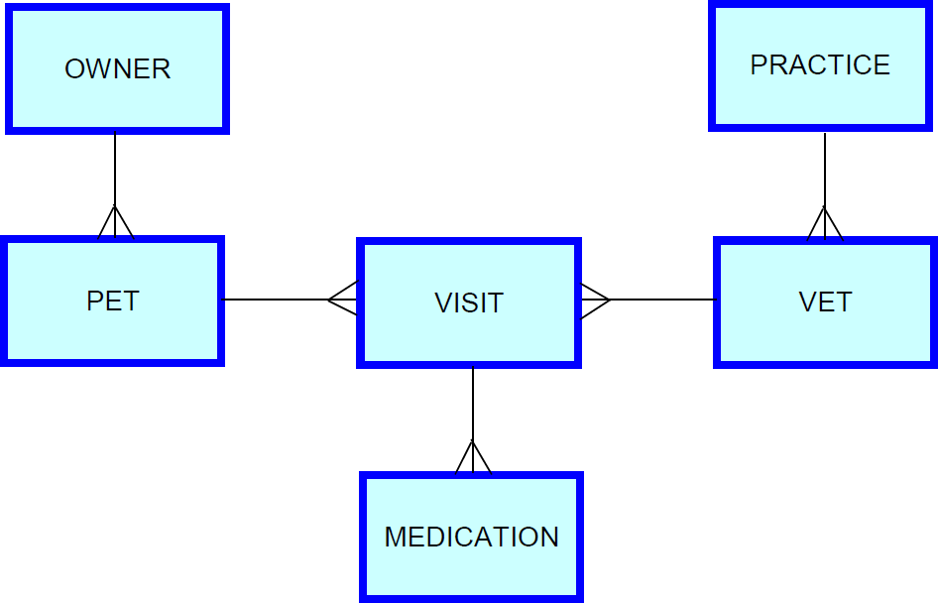

The Veterinary Surgery had employed a consultancy company to develop a database. However, unfortunately, that company had financial problems and is no longer trading. They only partially completed the implementation of the database.

One of the senior partners heard of your expertise in this area. He has called on your services to complete the creation a working database.

## The database so far

The consultancy company who previously worked on the database created the following tables and populated them with data. The primary key columns are shown in **bold**.

## Owner table

The owner table holds information about the owners of pets. Each owner is allocated a unique number to identify them. Details of an owner’s name, telephone number and address are stored.

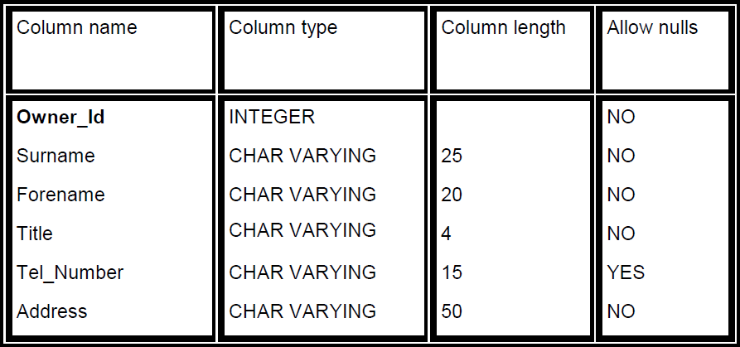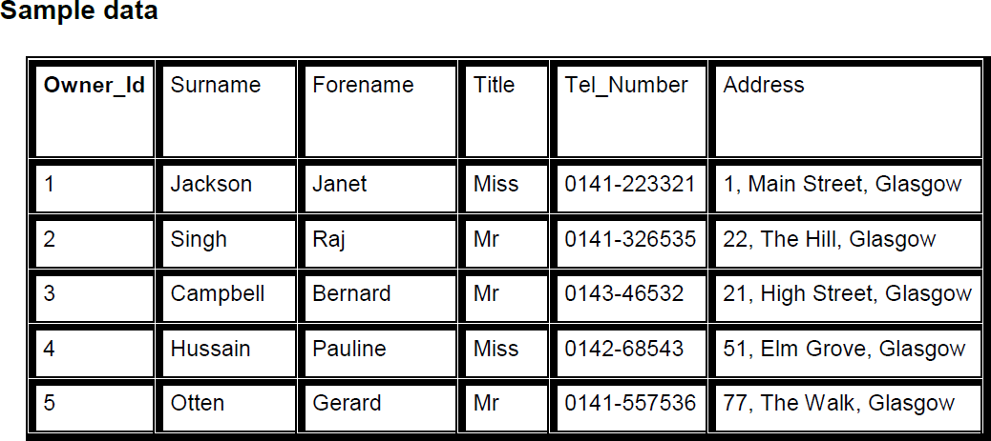

## Pet table

The pet table holds information about pets belonging to owners. Each pet is allocated a unique number to identify them. Details of a pet’s name, type, breed, gender, date of birth, its owner and any specific notes about the pet are stored.

## Structure

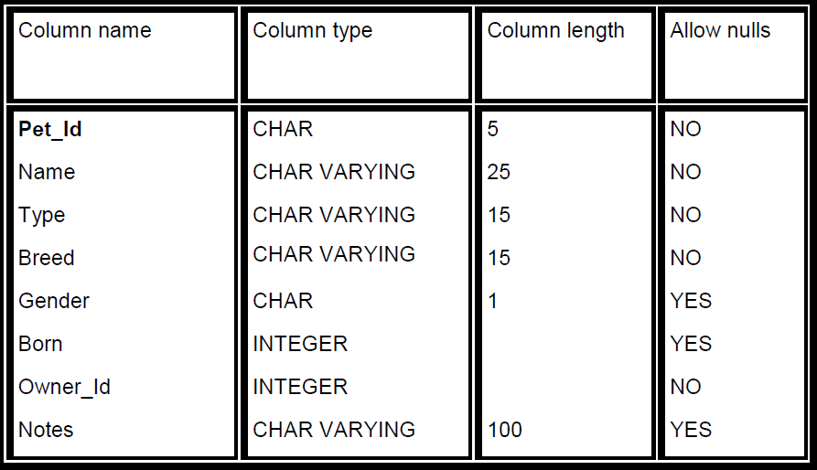

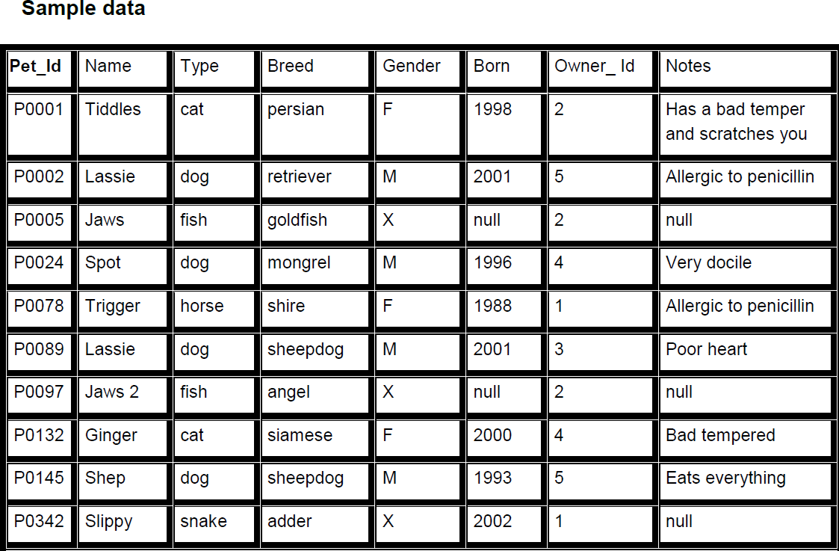

**Practice table**

The practice table holds information about the practices owned by the Healthy Pets Veterinary Surgery. Each practice is allocated a unique number to identify them. Details of the practice’s name and address are stored.

## Structure

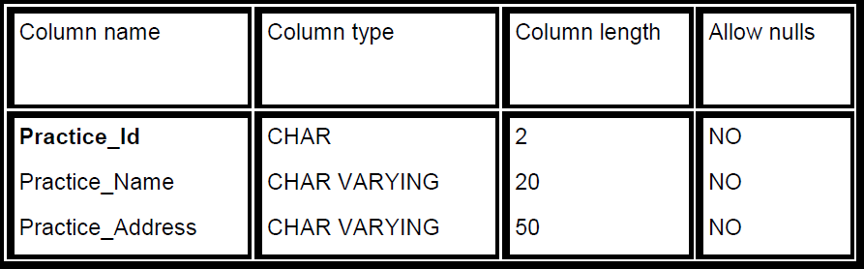

**Sample Data**

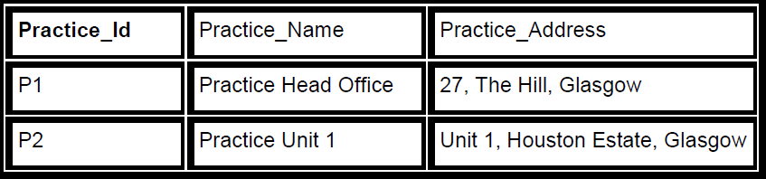

## Vet table

The vet table holds information about the vets who work for the Healthy Pets Veterinary Surgery. Each vet is allocated a unique number to identify them. Details of the vet’s name, telephone extension number, job position, salary and the practice in which they currently work are stored.

## Structure

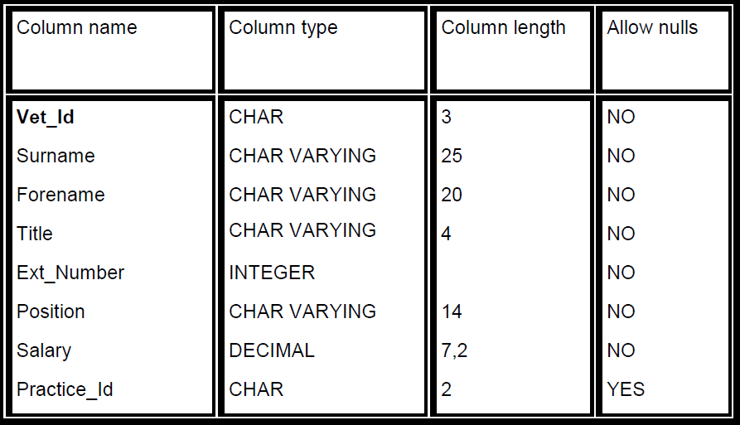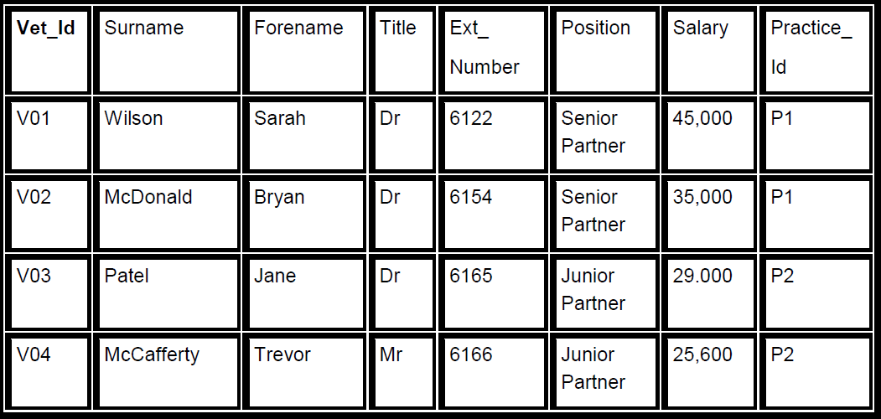

**Assessment instructions**

Having read the information, given to you by your tutor, on setting up the Data and Schema document ‘Healthy Pets Veterinary Surgery’, you are required to finish the partially completed data model by creating the remaining two tables, VISIT and MEDICATION.

## Example historical data to be held in these tables is show below. Visit table

**Medication table**

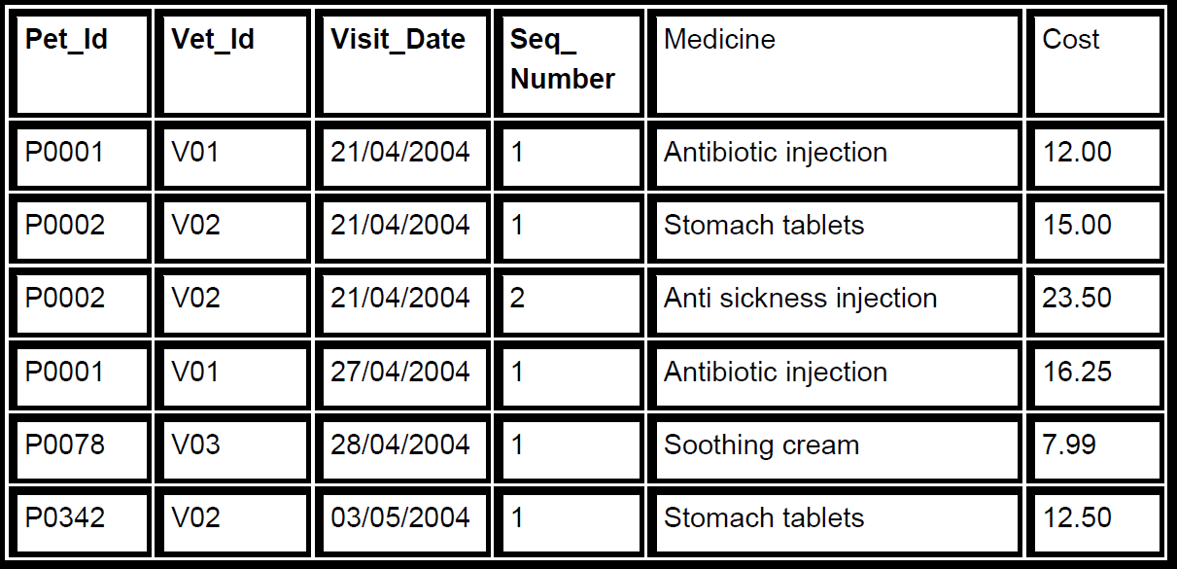

Note **—**

***The primary keys are shown in bold. More than one column, in each table, is required to define the primary key in order to uniquely identify each row.***

In order to perform the following tasks, you will need to create the four tables developed so far. Use the Data and Schema Document to help you set this up.

## Assessment tasks

To achieve this Outcome you must complete all of the following tasks:

## Task 1:

Create the VISIT and MEDICATION tables, including their primary key definitions.

**Answer 1:**

-- Create the visit table

CREATE TABLE visit

( pet_id CHAR(5) NOT NULL,

vet_id CHAR (5) NOT NULL,

visit_date DATE NOT NULL,

basic_cost DECIMAL(7,2) NOT NULL,

symptom CHAR VARYING(100) NOT NULL,

treatment CHAR VARYING(100) NOT NULL,

PRIMARY KEY (pet_id,vet_id, visit_date)

);

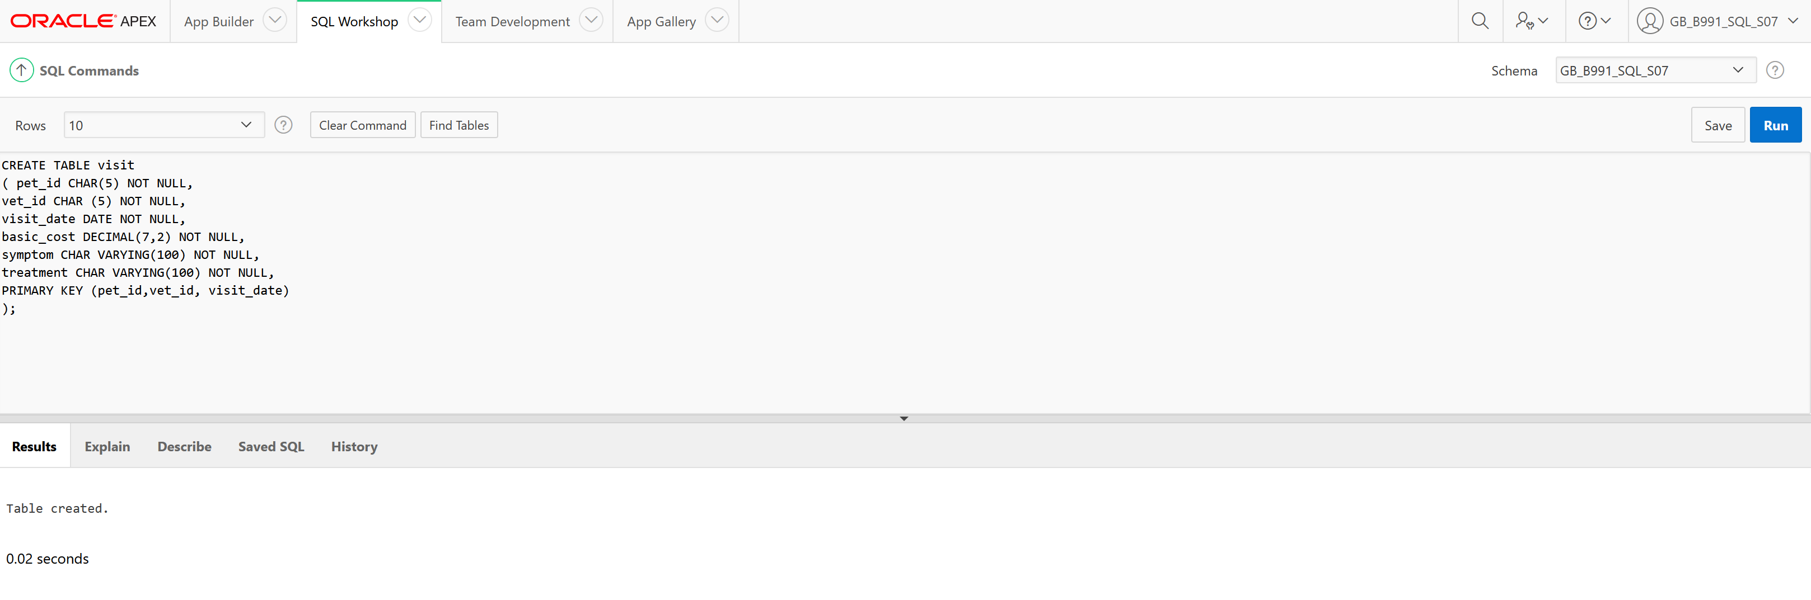

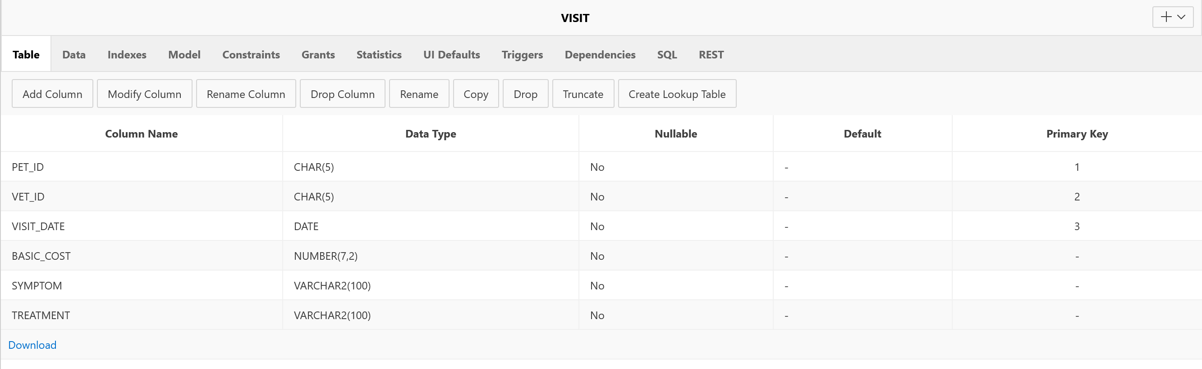

-- Create the medication table

CREATE TABLE medication

( pet_id CHAR(5) NOT NULL,

vet_id CHAR (5) NOT NULL,

visit_date DATE NOT NULL,

seq_number CHAR(2) NOT NULL,

medicine CHAR VARYING(30) NOT NULL,

cost DECIMAL(7,2) NOT NULL,

PRIMARY KEY (pet_id,vet_id, visit_date, seq_number)

);

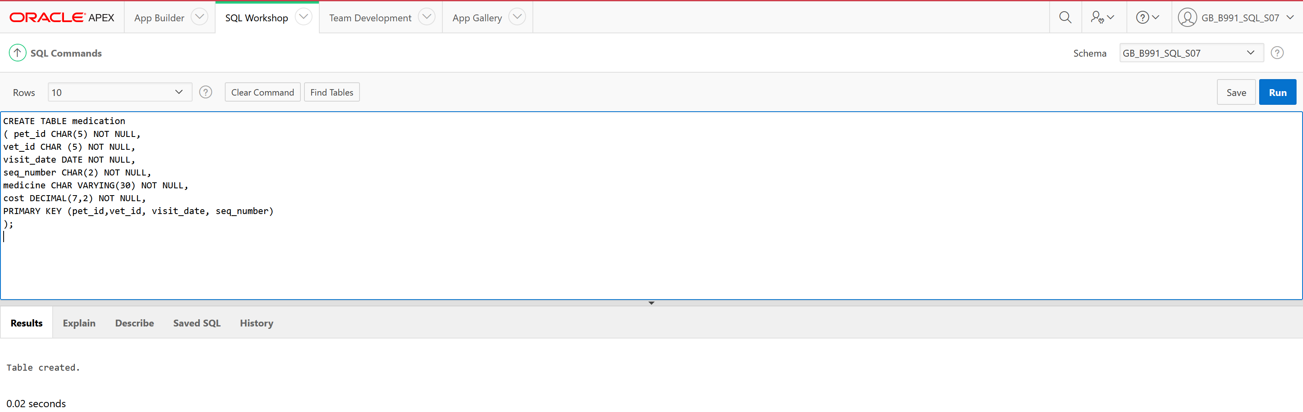

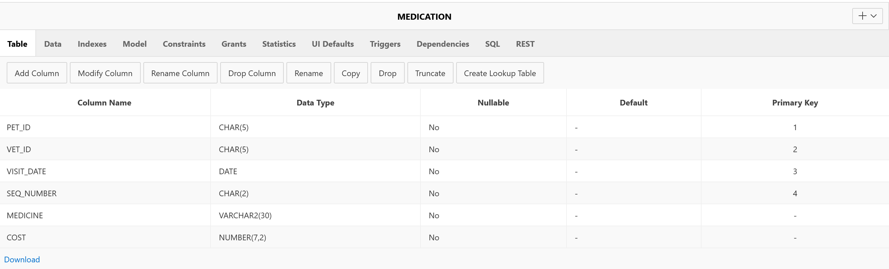

## Task 2:

Insert values into each table

**Answer 2:**

-- Insert data into the visit table

INSERT INTO visit VALUES ('P0001', 'V01', '21-april-2004', '23.99', 'Bitten left ear', 'Injection');

INSERT INTO visit VALUES ('P0002', 'V02', '21-april-2004', '14.75', 'Vomiting', 'Tablets and injection');

INSERT INTO visit VALUES ('P0001', 'V01', '27-april-2004', '20.00', 'Bitten right ear', 'Injection');

INSERT INTO visit VALUES ('P0078', 'V03', '28-april-2004', '15.00', 'Limping', 'Ointment');

INSERT INTO visit VALUES ('P0342', 'V02', '03-may-2004', '12.50', 'Not eating', 'Tablets');

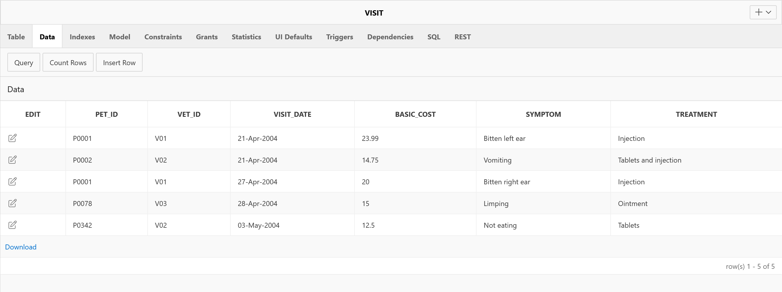

-- Insert data into the medication table

INSERT INTO medication VALUES ('P0001', 'V01', '21-april-2004', '1', 'Antibiotic injection', '12.00');

INSERT INTO medication VALUES ('P0002', 'V02', '21-april-2004', '1', 'Stomach tablets', '15.00');

INSERT INTO medication VALUES ('P0002', 'V02', '21-april-2004', '2', 'Anti sickness injection', '23.50');

INSERT INTO medication VALUES ('P0001', 'V01', '27-april-2004', '1', 'Antibiotic injection', '16.25');

INSERT INTO medication VALUES ('P0078', 'V03', '28-april-2004', '1', 'Soothing cream', '7.99');

INSERT INTO medication VALUES ('P0342', 'V02', '03-may-2004', '1', 'Stomach tablets', '12.50');

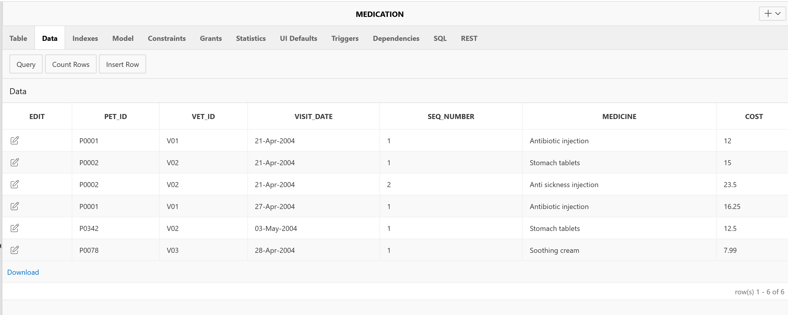

## Task 3:

Shep the dog has a sore foot. On the 22 June 2004 he visited the vet and was attended to by the vet Dr Sarah Wilson. He was given an injection and some ointment. The basic cost for this treatment was £15.00. Add a row to the VISIT table to store details of this visit.

**Answer 3:**

Dog Shep ID number 145

Dr. Sarah Wilson works in a veterinary clinic with ID 01

so the row will look like:

-- Insert data into the visit table

INSERT INTO visit VALUES ('P0145', 'V01', '22-june-2004',’15.00’, 'Sore foot', 'Injection and ointment');

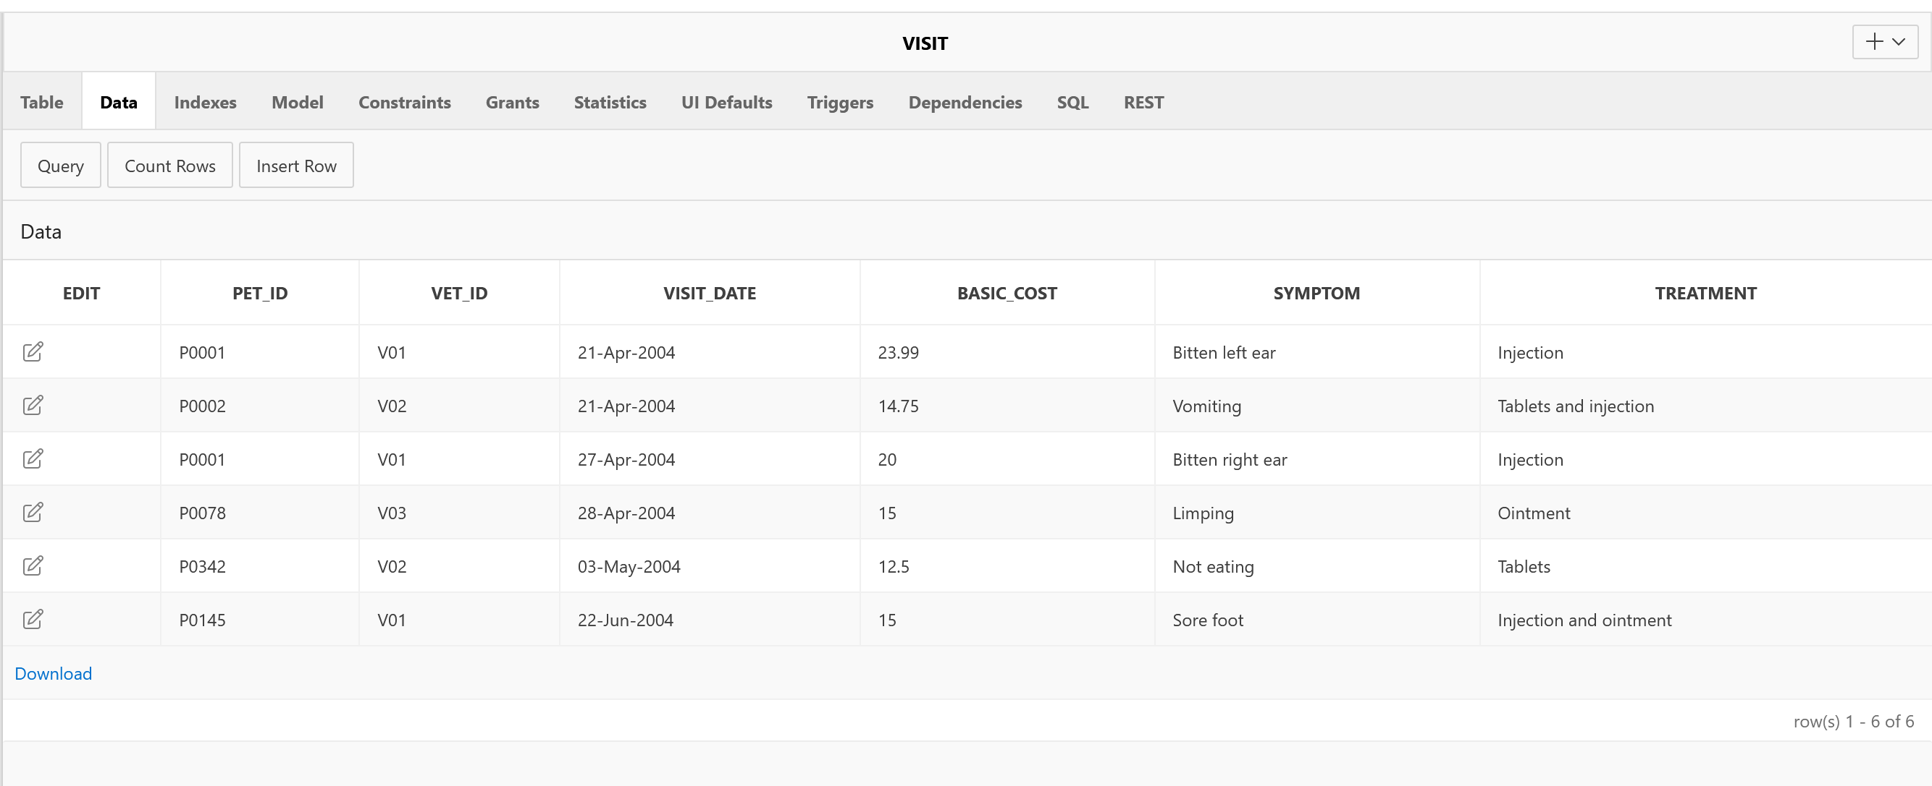

## Task 4:

The injection given was an antibiotic costing £17.89 and the ointment given was a pot of ‘Soothing Cream’ costing £12.50. Add two rows to the MEDICATION table to store details of these medications.

**Answer 4:**

-- Insert data into the medication table

INSERT INTO medication VALUES ('P0145', 'V01', '22-june-2004', '1', 'Antibiotic injection', '17.89');

INSERT INTO medication VALUES ('P0145', 'V01', '22-june-2004', '2', 'Soothing cream', '12.50');

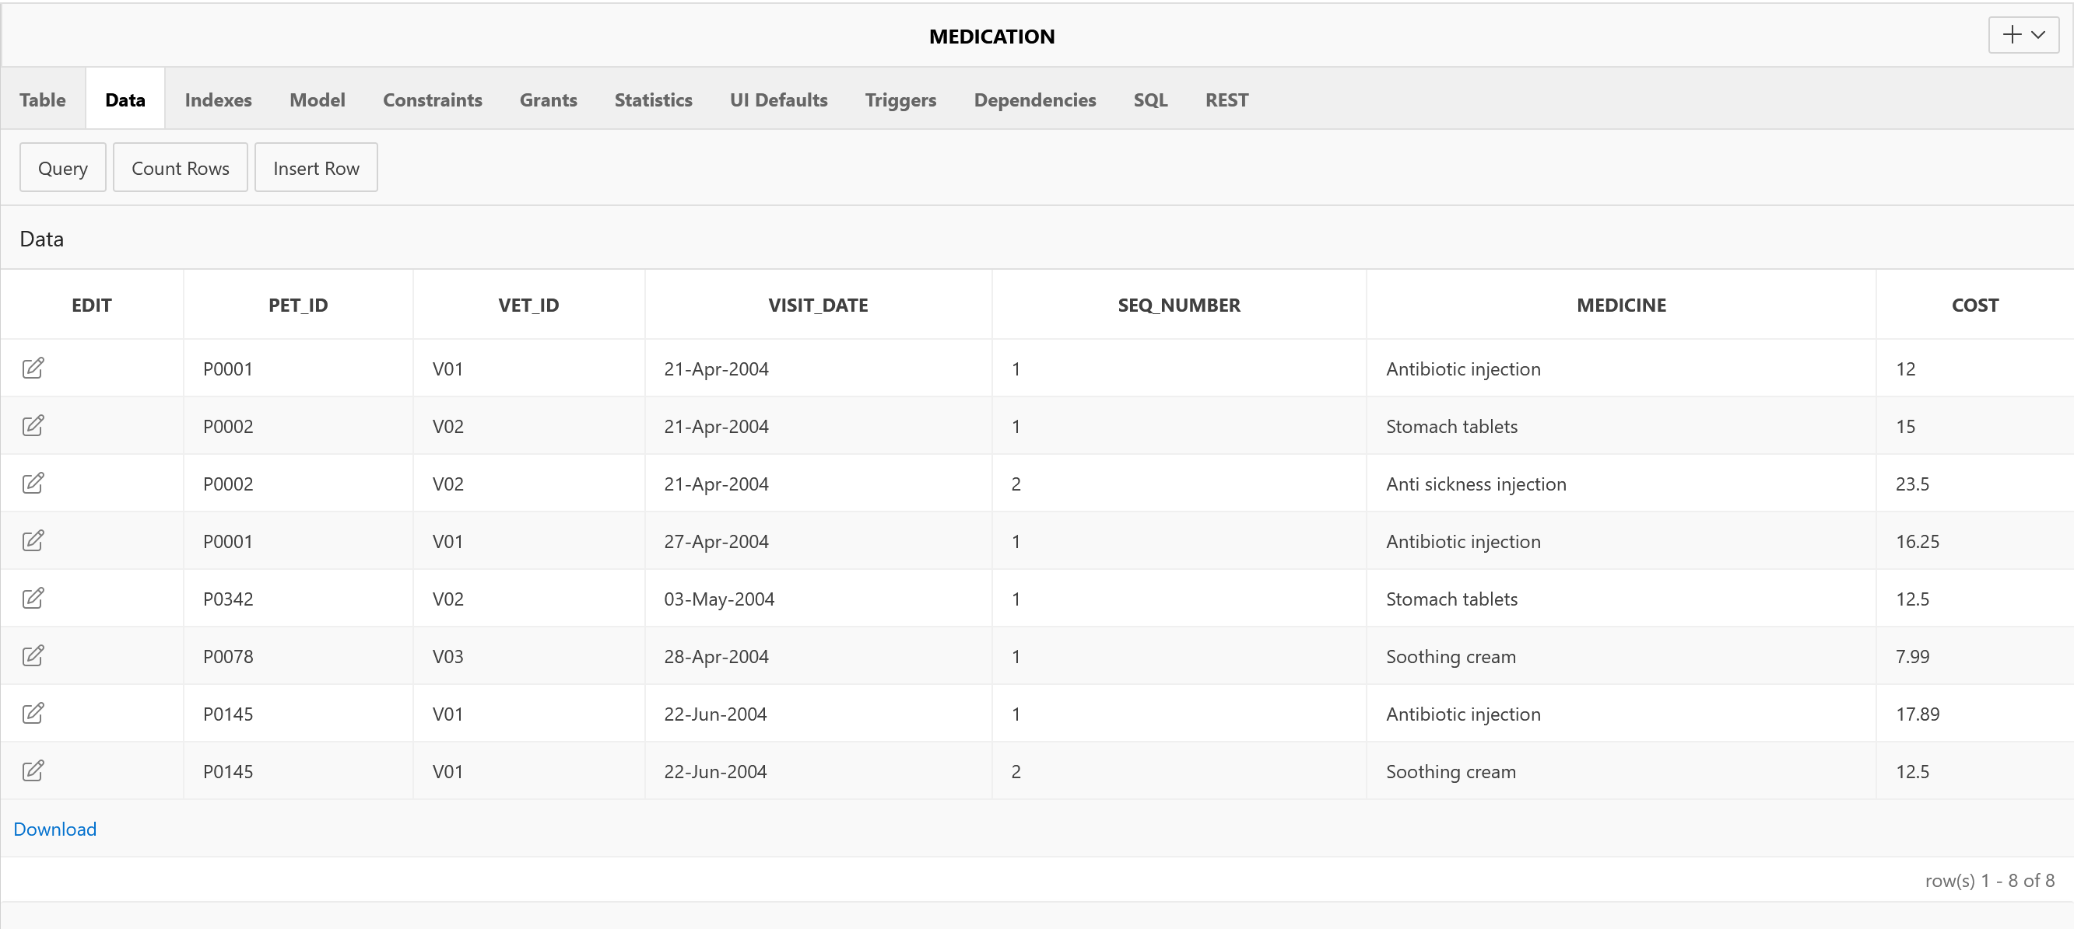

## Task 5:

Remove the PRACTICE table.

**Answer 5:**

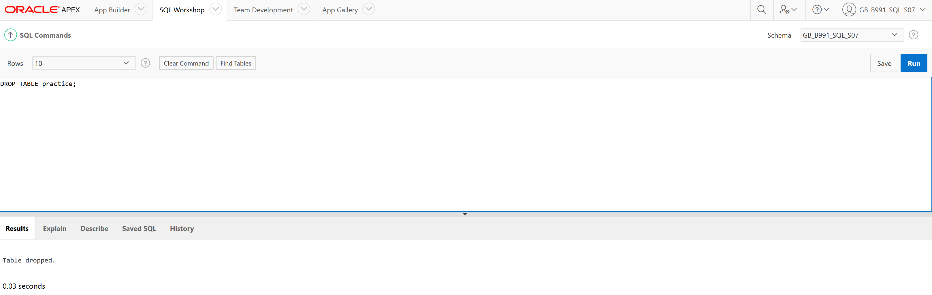

## Task 6:

Remove the PRACTICE_ID column from the VET table.

**Answer 6:**

ALTER TABLE vet

DROP COLUMN practice_id;

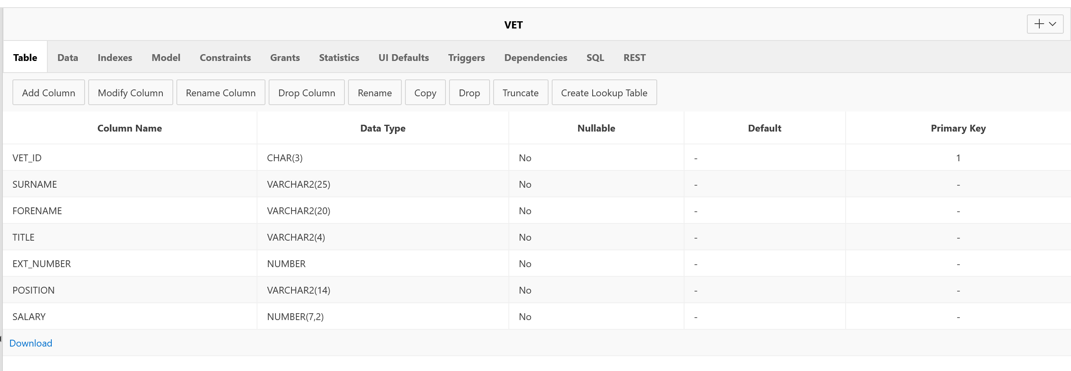

## Task 7:

Add a column to the VET table to hold their mobile phone number. Use an appropriate name, type and length for this column.

**Answer 7:**

ALTER TABLE vet

ADD mobile_number CHAR VARYING(15);

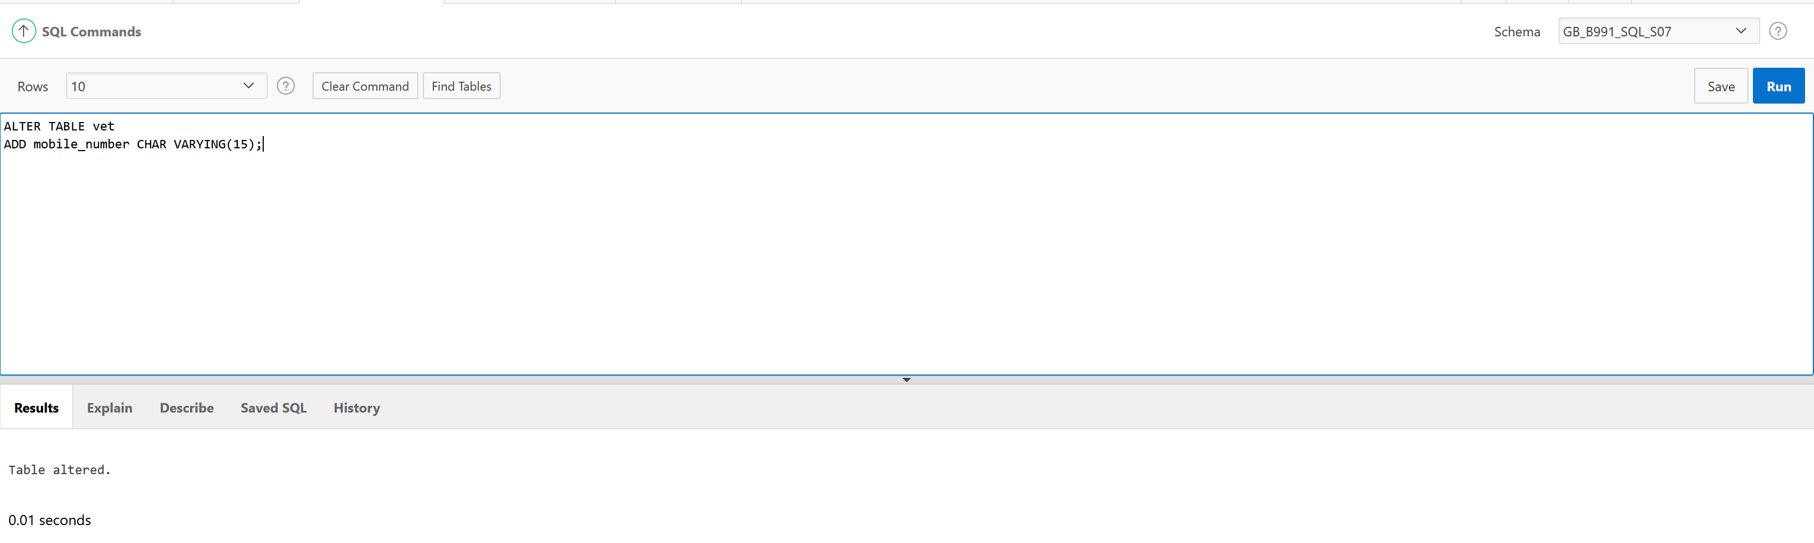

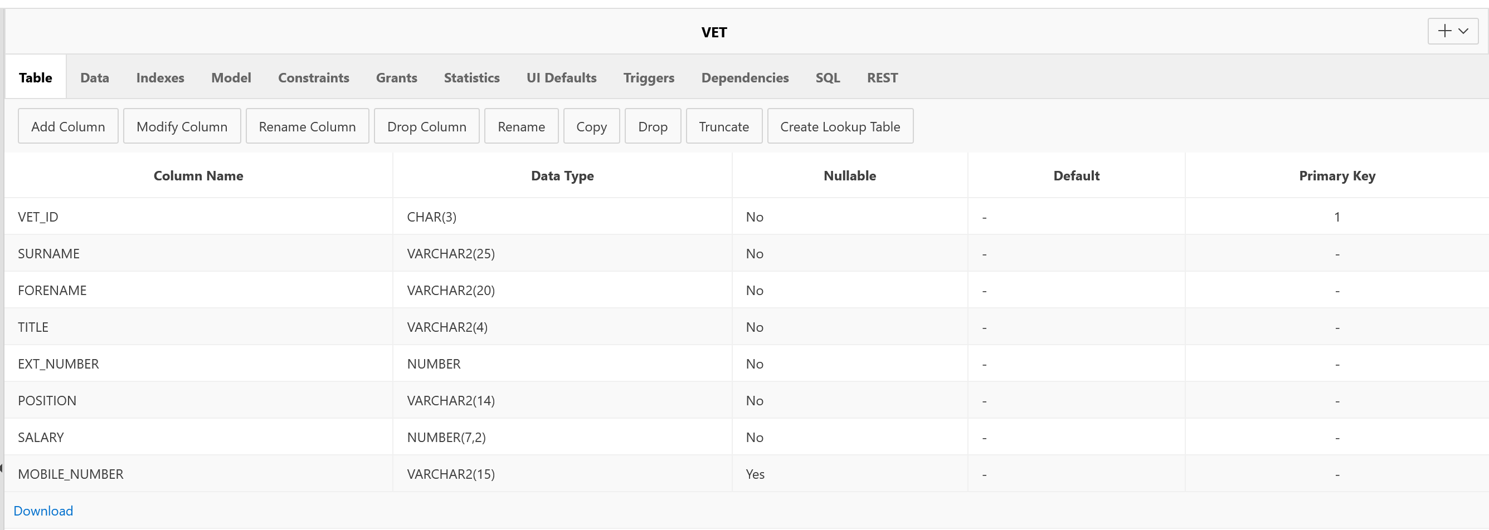

## Task 8:

Add details of the two new junior partners. One of these new vets is you; choose appropriate data for this and the other row. As yet, you have not been given a mobile phone. Remember, the structure of the VET table has changed because of the modifications above.

**Answer 8:**

-- Insert data into the vet table

INSERT INTO vet VALUES ('V05', 'Savchuk', 'Diana', 'Miss', 6180, 'Junior Partner', 29000, null);

INSERT INTO vet VALUES ('V06', 'Mills', 'Jeremy', 'Mr', 6181, 'Junior Partner', 29000, null);

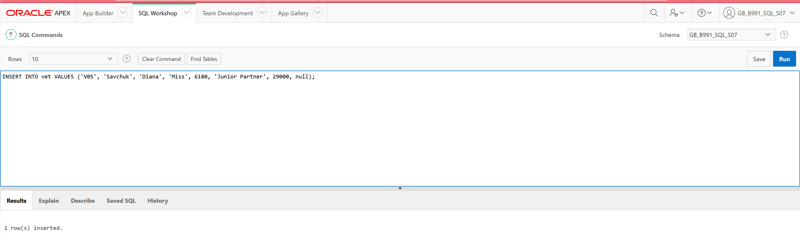

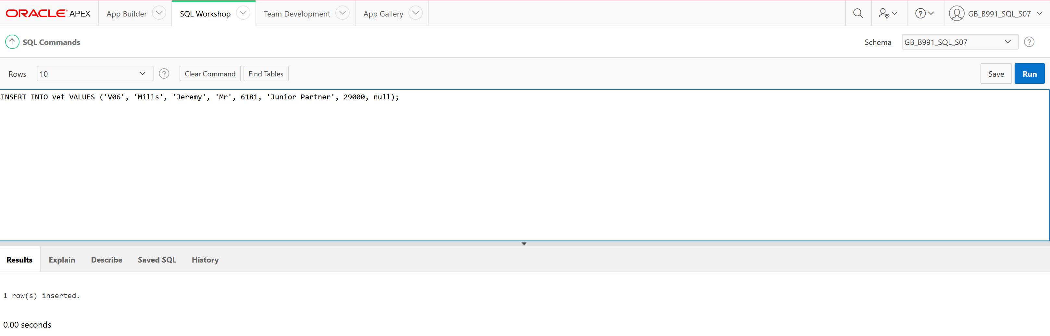

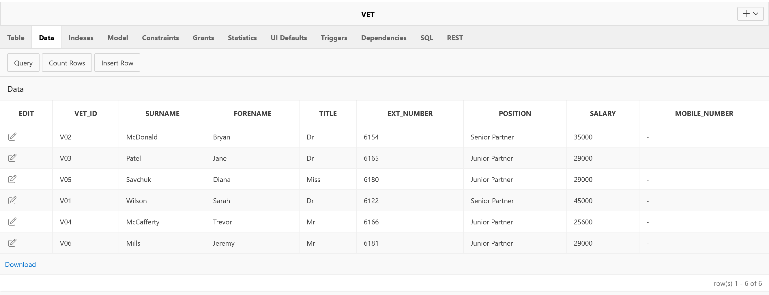

## Task 9:

Produce a listing of all the rows and columns in the VET, VISIT and MEDICATION tables.

**Answer 9:**

